Technical

Data

Sheet

Productc Name：PLCC-5050 White SMD Chip LE

Partar Numbere ： HT -

Customer：

Customer P ：

Versiono No. ：

A.2

UWUWUWC(S)S

Date：

2009.01.01

Customer Approval

Instituted By：

Checked By:

Approved By：

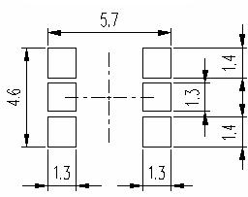

1、Features
Technical Data Sheet
Part No : HT61-2301UWUWUWC(S)
V ersion A.2 Issued date 2009.01.01 Page

1 of 10

� Package ( L/W/H ) : 5.4 × 5.0 × 1.6 mm
� Color : Ultra Bright Standard White
� Lens: Y ellowDiffuse Flat Mold
� EIA STD Package
� Meet ROHS, Green Product
� Compatible With SMT Automatic Equipment
� Compatible With Infrared Reflow Solder And WaveSolder Process

2、 Packagek g Profile Solderir n PAD Suggested

①

③

⑤

MARK

Φ3.3

②

④

⑥

①

③

⑤

Polatity

②

④

⑥

①

②

③

Notes: 1. All dimensions are in millimeters ;
2. Toleranceis ± 0.10 mm unless otherwise noted.

Harvatek Technical Data Sheet
Part No : HT61-2301UWUWUWC(S)
V ersion A.2 Issued date 2009.01.01 Page

3、 Solderingr n Profile Suggeste

3.1、For Lead Solder
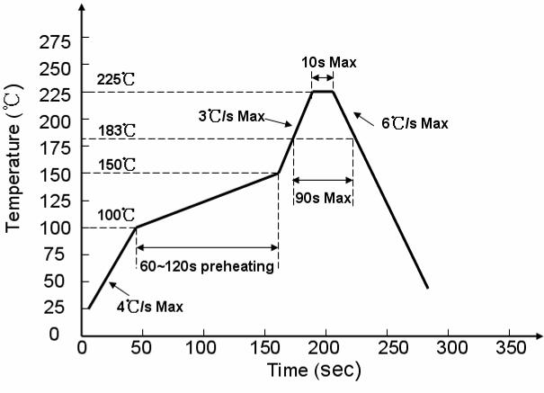

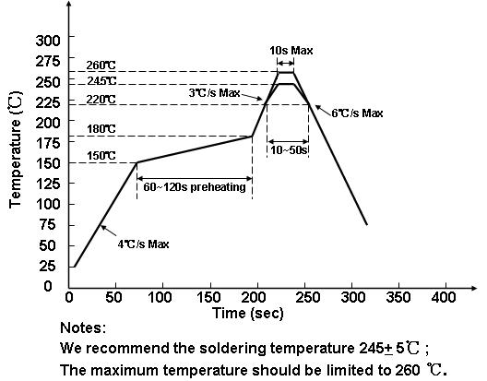
3.2、For Lead Free Solder

2 of 10

Technical Data Sheet
Part No : HT61-2301UWUWUWC(S)
V ersion A.2 Issued date 2009.01.01 Page

4． Absolute Maximum Ratings At Ta=25℃

3 of 10

Parameter

Power Dissipation

Symbol

Pd

W1
W2
W3

Rating

90
90
90

Unit

mW

Peak Forward Current
(1/10 Duty Cycle, 0.1ms Pulse Width)

DC Forward Current

Reverse V oltage

Operating Temperature Range

Storage Temperature Range

IFP

IF

VR

Topr

Tstg
W1
W2
W3
W1
W2
W3
W1
W2
W3
100
100
100
30
30
30
5
5
5

-30°C ~ + 85°C

-40°C ~ + 90°C

mA

mA

V

Soldering Condition

Tsol

Reflow soldering : 260°C For 5 Seconds
Hand soldering: 300°C For 3 Seconds

Technical Data Sheet
Part No : HT61-2301UWUWUWC(S)
V ersion A.2 Issued date 2009.01.01 Page

5、 Electrical Optical Characteristics At Ta=25℃

4 of 10

Parameter

Symbol

Color

W1

Min.

---

Typ. Max. Unit

1200 ---

Test Conditi

Luminous Intensity

CIE 1931 Coordinate

Forward V oltage

Reverse Current

Viewing Angle
IV

X/Y

VF

IR

2θ1/2
W2
W3

W1

W2

W3

W1
W2
W3
W1
W2
W3
---
---
---

---

---

---

2.8
2.8
2.8
---
---
---
---
1200
1200
X:0.29
Y:0.29
X:0.29
Y:0.29
X:0.29
Y:0.29
---
---
---
---
---
---
120
---
---

---

---

---

3.6
3.6
3.6
10
10
10
---
mcd

nm

V

uA

deg
IF = 20mA/dice

IF=20mA/dice

IF=20mA /dice

VR=5V

IF = 20mA/dice

Notes: 1. Luminous intensity is measured with a light sensor and filter combination that approximates the
CIE eye-response curve.
2. θ1/2 is the off-axis angle at which the luminous intensity is half the axial luminous intensity.
3. The dominant wavelength, λd is derived from the CIE chromaticity diagram and represents the
single wavelength which defines the color of the device.

